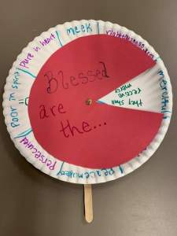
Craft: “Wheel of Beatitudes”

You will need:

Bible: Look up Matthew 6:1-12

Craft Supplies
- Paper or cardstock
- Paper plates
- Brad fasteners
- Scissors
- Decorative materials (markers, crayons, etc.)
- Popsicle sticks (optional)

Procedure and Directions
- Cut the construction paper into a circle, slightly smaller than the paper plate.
- Divide the plate into 8 sections, drawing lines like a “pie.”
- Write the words that describe the people God blesses in each beatitude verse on the outside rim of the paper plate, giving one to each section (“meek,” “pure in heart,” etc.).
- Inside each wedge, write the promise attached to the verse (For example: in the wedge marked “Meek”, write “they shall inherit the earth”; In the wedge marked “Merciful”, write “they shall receive mercy”, etc.).
- Cut a triangular piece out of the circular paper so that one “slice” of the wheel is fully available at a time. On the paper, decorate with the words, “Blessed are the….”
- Line up the paper on top of the plate, and carefully poke the brad through the center of both. This may require a pre-punched hole with scissors. Fold out the prongs of the brad to hold it in place.
- Spin the “wheel” to learn the beatitudes!
- Attach the plate to a popsicle stick for ease of carrying, if desired.

