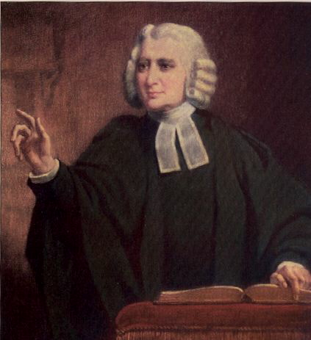
This Photo by Unknown Author is licensed under CC BY-SA
Charles Wesley on Singing in Church (Intro to the United Methodist Hymnal)
Wesley’s directions for singing are meant to offer practical ways we worship together.

Directions for Singing. That this part of Divine Worship may be the more acceptable to God, as well as the more profitable to yourself and others, be careful to observe the following directions.
- I. Learn these Tunes before you learn any others; afterwards learn as many as you please.
- II. Sing them exactly as they are printed here, without altering or mending them at all; and if you have learned to sing them otherwise, unlearn it as soon as you can.
- III. Sing All. See that you join with the congregation as frequently as you can. Let not a slight degree of weakness or weariness hinder you. If it is a cross to you, take it up and you will find a blessing.
- IV. Sing lustily and with good courage. Beware of singing as if you were half dead, or half asleep; but lift up your voice with strength. Be no more afraid of your voice now, nor more ashamed of its being heard, than when you sung the songs of Satan.
- V. Sing modestly. Do not bawl, so as to be heard above or distinct from the rest of the congregation, that you may not destroy the harmony; but strive to unite your voices together, so as to make one clear melodious sound.
- VI. Sing in Time. Whatever time is sung, be sure to keep with it. Do not run before nor stay behind it; but attend closely to the leading voices and move therewith as exactly as you can. And take care you sing not too slow. This drawling way naturally steals on all who are lazy; and it is high time to drive it out from among us and sing all our tunes just as quick as we did at first.
- VII. Above all sing spiritually. Have an eye to God in every word you sing. Aim at pleasing him more than yourself, or any other creature. In order to this attend strictly to the sense of what you sing, and see that your Heart is not carried away with the sound, but offered to God continually; so shall your singing be such as the Lord will approve of here, and reward when he cometh in the clouds of heaven.
Wesley's Directions for Singing - United Methodist Insight (um-insight.net)

